COMP639 Project 2

Sprint 1 Review Summary Report

Semester 1 2023

Group 3

APRIL-JUNE 2023

Group 3:

Authored by: H Dai (1155066), S Duan (1155117),

M Sang (1114842), M Tian (1154238) and B Willis (1152570)

# Sprint 1 Review Summary Report

## ACTIVITIES

|  |  |  |  |  |
| --- | --- | --- | --- | --- |
| **Meeting Type** | **Date** | **Time** | **Duration** | **No. attend** |
| **WEEK 1** |  |  |  |  |
| Sprint 1 scrum | Monday 1 May | 7:30pm | 0.8hr | 5 |
| Meet PO/Scrum | Tuesday 2 May | 7:30pm | 1hr/1.8hr | 5 |
| Sprint 1 scrum | Wednesday 3 May | 7:30pm | 0.25hr | 5 |
| Sprint 1 scrum | Thursday 4 May | 7:30pm | 0.5hr | 3 |
| Sprint 1 scrum | Friday 5 May | 7:30pm | 0.25hr | 5 |

S

## SPRINT 1 PROGRESS

|  |  |  |  |  |
| --- | --- | --- | --- | --- |
| **To do/User Story** | **Priority/Sprin**t | **Acceptance Criteria** | **Status** | **Hours Worked** |
| ERD - Database Design - Database creation | 1 |  | DONE | Belinda-7.5  Hido-1  Miao-1 |
| User Flow Diagram - research other systems | 1 |  | DONE | Sherlyn-4  Belinda-2 |
| planning - calculations for the leave ... | 1 |  | DONE | Mia-4  Miao-4 |
| research all systems | 1 |  | DONE | Sherlyn-8  Mia-3  Hido-6 |
| prototype - using figma or balsamiq | 1 |  | DONE | Miao-8  Mia-6  Belinda-3 |
| As an employee, I want to log in to the leave management system with my credentials so that I can apply for leave. | 1 | * The login page should be secure and encrypted, such as using bcrypt to secure password. (PO just wants hidden) * The system should authenticate email and password. * The system should display an error message if my email or password is incorrect. * After logging in, users should see the dashboard - just one for everyone (other roles will see extra buttons) | DONE | Belinda-14 |
| As an employee, I want to view my own details such as Title (e.g., Doctor/Professor/Mr/Mrs), First Name, Family Name, Joined Date, Position Title, Position Start Date, Department, reports to, approval manager so that I can ensure that my records are accurate. | 1 | * Users can click on Account to view details. * The system will display Name (including title), username, joined date, position title, position start date, department, reports to name, approval manager name. | DONE | Hido-4 |
| As an employee, I want to be able to see my current leave balance. (as at close of last pay - balance is stored in the database and is updated fortnightly) … so that I can plan my leave requests accordingly. | 1 and 2 | * Leave balance needs to be stored in hours but displayed in days. * For Annual Leave (at close of last pay), it should include annual leave balance (stored in the database), Leave approved not paid (calculated), Leave applied not yet approved. (calculated) * For Sick Leave, (at close of last pay), it should include sick leave balance (stored in the database), Leave approved not paid, (calculated) Leave applied not yet approved. (calculated) | In progress | Sherlyn-10 |
| As an employee, I want to be able to see my projected leave balance for a particular date so that I can plan my leave requests accordingly. | 1 to 3 | * The system should allow employees to select a future date for which they want to view their projected leave balance. * The system should calculate the projected leave balance based on the employee's leave accrual rate and any approved, pending, or rejected leave requests. * The system should display the projected leave balance (hours and days) for the specified date. * The system should inform the employee if the selected date is in the past or if it's invalid. | In progress | Mia-10 |
| As an approval manager or admin, I want to be able to view requests so that I can process them accordingly. | 1 | * The system should display a clickable list of new leave requests on the approval manager's dashboard upon login. * The system should provide a "To Do" or "Action Items" section on the dashboard where the approval manager can view and action leave requests with relevant details. * The system should allow the approval manager to view the full details of a leave request. | In progress | Miao-3.5 |

## SPRINT 1 RETROSPECTIVE

|  |  |  |
| --- | --- | --- |
| * What worked well? | What did not go well or as expected? | What should we try doing next? (Learnings) |
| Team is working cohesively and supportively, a lot more time was spent in the planning phase and we are all on board with the design | only one person filling out the README file | fill out the README file every time you do a commit - talk about your decisions and why; fill out the excel spreadsheet on Daily Activity Log with times spend on task, when you finish your user story change the status so the next person can test it |
| Team skill is well balanced, that each pieces of the work has fit together perfectly to create a cohesive and successful outcome | I didn't fill out the documentation |  |
| We worked together on some same tasks so that we could help each other more and learn from others. Everyone was contributing to the design part this time, so we understand what we want to achieve. We did lots of research and shared with others before we started coding. | spent too much time on tasks, not development (personal ), so that I did not finish my sprint one function on time | time management and focus more on development. |
| We spent more time on searching and design part than first project. In this way, we could be clearer of the result we want to achieve. We reduced the meeting time which give us more time to focusing on the tasks. | Start a function which need some other dependency functions, should allocate this task to later sprint. | Dive more into each user stories and each task before coding. |
| With the experience gained from the previous project, we were better prepared for the new project this time around, and everyone had a better understanding of what to do at the beginning of a new project. | for this more complex project, we are still somewhat unclear about the flow of the website and are still figuring out how to implement certain features. | We now have a better understanding of what we need to do at the beginning of a new project, which will help us with our preparation and planning. Additionally, we have learned from the challenges we faced during our project, which will better equip us to handle similar situations in the future. |
|  |  |  |

## SPRINT 2 PLANNING

|  |  |  |  |  |  |
| --- | --- | --- | --- | --- | --- |
| **User Story** | **Priority/Sprin**t | **Acceptance Criteria** | **Dev** | **Status** | **Hours Estimated** |
| As an employee, I want to be able to see my current leave balance. (As at close of last pay - balance is stored in the database and is updated fortnightly), so that I can plan my leave requests accordingly. | 2 | * **Leave balance needs to be stored in hours but displayed in days.** * **For Annual Leave (at close of last pay), it should include annual leave balance (stored in the database), Leave approved not paid (calculated) , Leave applied not yet approved. (calculated)** * **For Sick Leave, (at close of last pay), it should include sick leave balance (stored in the database), Leave approved not paid, (calculated) Leave applied not yet approved. (calculated)** | Sherlyn | In Progress | 6 |
| As an employee, I want to be able to see all my leave requests and their status (approved, unapproved, or rejected), so that I can plan my work schedule accordingly. | 2 | * The system should display all leave requests, if possible, allow users to sort and filter leave requests by different criteria such as date or status... * For each request, the system should display the type of leave, start and end dates, reason for leave, approval manager and status. | Mia | In Progress | 12 |
| As an Approval Manager/ and Admin, I want to be able to view leave requests, so that I can process them accordingly. | 2 | * **The system should display a clickable list of new leave requests on the approval manager's dashboard upon login.** * **The system should provide a "To Do" or "Action Items" section on the dashboard where the approval manager can view and action leave requests with relevant details.** * **The system should allow the approval manager to view the full details of a leave request.** | Miao | In Progress | 8 |
| As a Approval Manager, I want to be able to search for a particular leave request (search by employee or date or something else - restrict based on role), so that I can quickly locate and review it. | 2 | * **The system should provide a search bar on the leave request page for approval managers.** * **The system should allow approval managers to search for leave requests by different criteria (e.g., employee name, leave dates, leave type, status).** * **The system should display search results with relevant details and allow the approval manager to take actions as needed.** | Hido | In Progress | 12 |
| As an Approval Manager, I want to be able to see a list of all employees that I have delegated authority to approve leave for and view their balances, and requests (admin can see anything or anyone but can’t approve their own leave), so that I can make decisions. | 2 | * **The system should display a list of employees under the approval manager's authority.** * **The system should allow the approval manager to view employee details, balances (in hours and days), and requests for a selected employee.** * **The system should provide a Projected Balance Calculator for the employee.** | Belinda | In Progress | 12 |

## BURNDOWN CHART

1. Adjusted Database Design

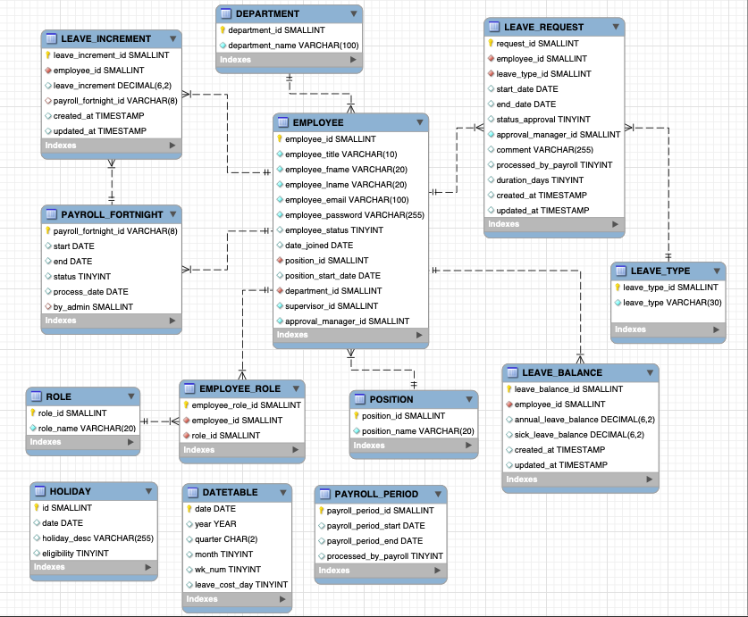

1. Employee Hierarchy Chart

